**Np-hard Np-Complete:**

**What is P?**

* P is set of all decision problems which can be solved in polynomial time by a deterministic.
* Since it can be solved in polynomial time, it can be verified in polynomial time.
* Therefore P is a subset of NP.

**P:** Whenever accident being met, the nearby people call the ambulance. The problem associated with this is that the victims depend on the mercy of nearby people. There is a chance that there are no people nearby the accident spot or people who are around neglects the accident. This is the flaw in the manual system.

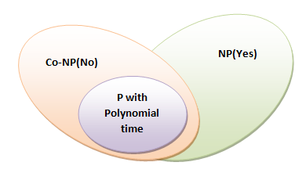

**What is NP?**

* "NP" means "we can solve it in polynomial time if we can break the normal rules of step-by-step computing".

**What is NP Hard?**

A problem is NP-hard if an [algorithm](http://mathworld.wolfram.com/Algorithm.html) for solving it can be translated into one for solving any [NP-problem](http://mathworld.wolfram.com/NP-Problem.html) (nondeterministic polynomial time) problem. NP-hard therefore means "at least as hard as any [NP-problem](http://mathworld.wolfram.com/NP-Problem.html)," although it might, in fact, be harder.

**NP-Hard:**

In propose system user will provide details to admin. Also user will provide the aadhar number to admin. Admin will add details and finger print to system. System will generate QR-Code and send to user email id. Only admin can add the information and photo of candidate into candidate list. User will login into system if user is already register with aadhar then user will scan QR-Code send by system on email. Then user will scan finger print. If QR-Code and finger print match into system then user can vote candidate. After voting admin can view vote and automatically identify winner candidate and result.

So here in this case the ‘P’ problem is NP hard.

i.e. P=NP-Hard

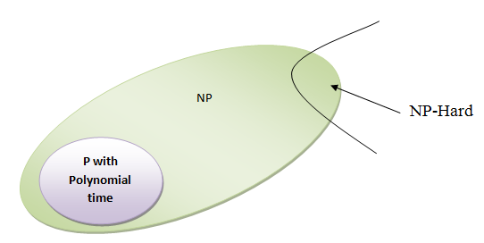

**What is NP-Complete?**

* Since this amazing "N" computer can also do anything a normal computer can, we know that "P" problems are also in "NP".
* So, the easy problems are in "P" (and "NP"), but the really hard ones are *only* in "NP", and they are called "NP-complete".
* It is like saying there are things that People can do ("P"), there are things that Super People can do ("SP"), and there are things *only* Super People can do ("SP-complete").

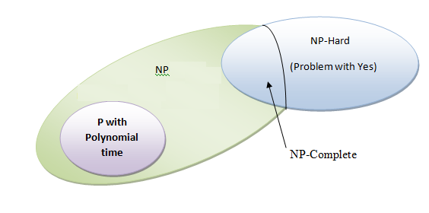

**NP-Complete:**

We have use Bloom filtering for detection of packet drop attack whether it is drop by itself or by hacker.

Hence the ‘P’ is NP-Complete in this case.